

|  |  |
| --- | --- |
| Student Name | Afzal Ali Ahmed Shah |
| Roll no | **2024-SE-04** |
| Semester | **2nd** |
| Instructor Name | **MAM. Sidra** |
| Subject | **CA&LD** |
| Course Code | **CS-1206** |
| Credit Hours | **3+1** |
| Date | **06-June-2025** |
| Department of Software Engineering | |

**Lab Report: Verification of DeMorgan’s Theorems**

**Objective:**

To **verify DeMorgan's Theorems** using logic gates and **simulate the circuits** using **Electronics Workbench (Multisim)**.

**Theory:**

DeMorgan's Theorems are two of the most important laws in Boolean algebra. They are used extensively to simplify and implement logic circuits.

**DeMorgan’s First Theorem:**

(A⋅B)’=A’+B’

This states that the **NAND** of A and B is **logically equivalent** to the **OR** of the complements of A and B.

**DeMorgan’s Second Theorem:**

(A+B)’=A’⋅B’

This states that the **NOR** of A and B is **logically equivalent** to the **AND** of the complements of A and B.

**Components Required:**

* **Electronics Workbench / Multisim**
* Logic Gates: AND, OR, NOT, NAND, NOR
* 2 Input switches (for A and B)
* 2 LEDs (for observing outputs)
* Connecting wires

**🔌 Circuit 1: DeMorgan’s First Theorem**

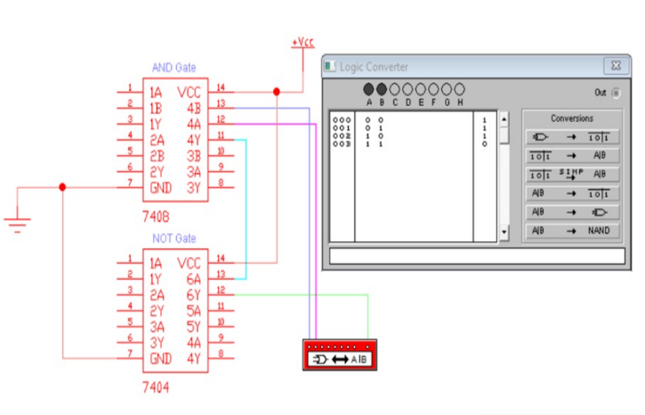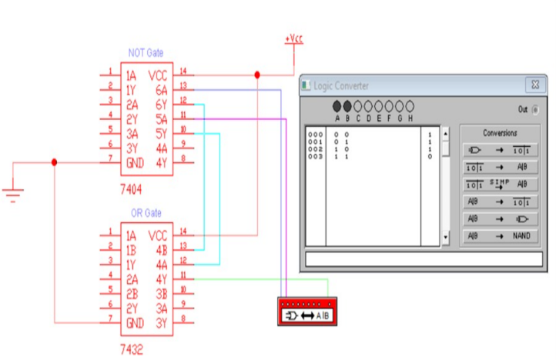 **(A⋅B)’=A’+B’ (TRUTH TABLE):**

**Circuit Diagram (by NAND GATE)*:***

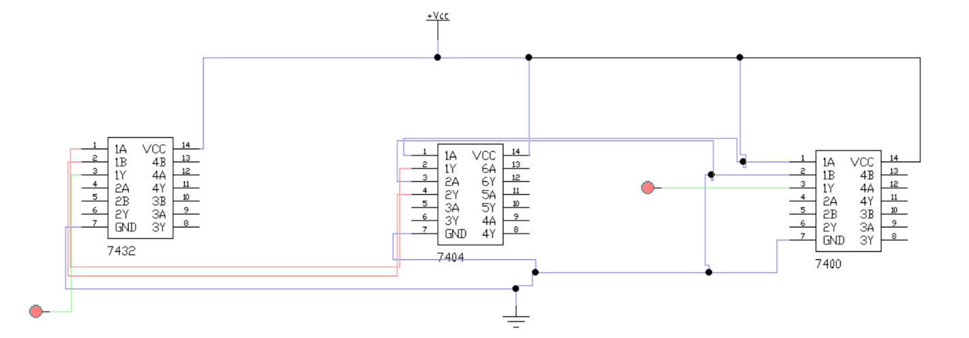

**When both are on:**

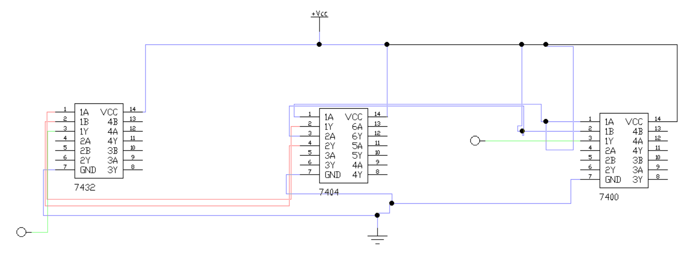

**When both are Off:**

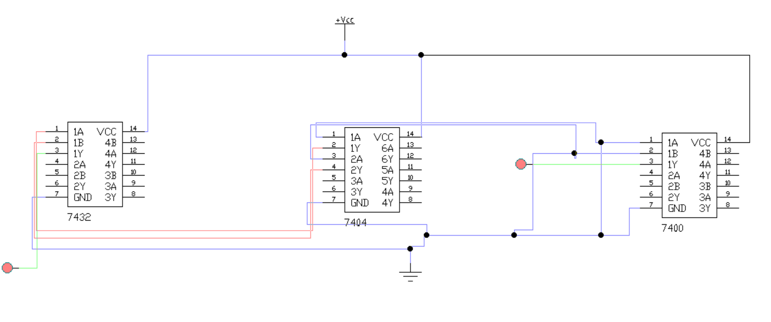  
**When one is on and second is off:**

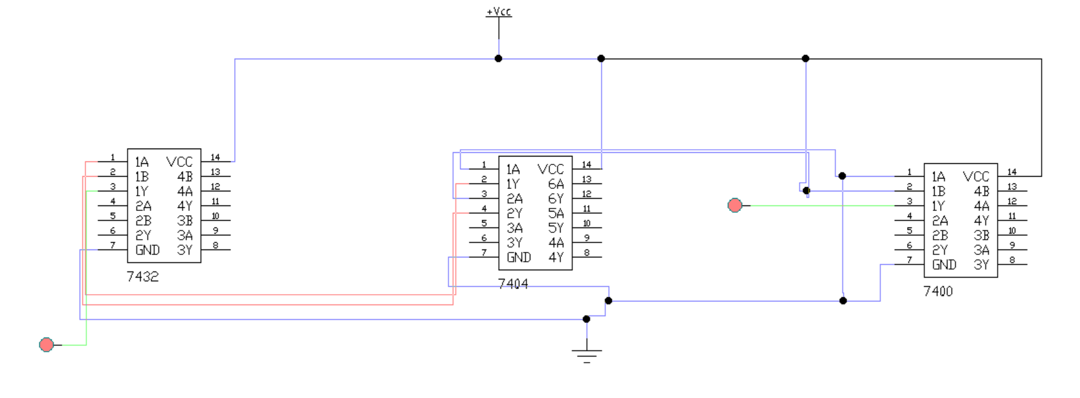

➡️ Compare both outputs using **two LEDs** (must glow identically).This is complete proof of the DeMorgan’s law.

**Truth Table - First Theorem**

|  |  |  |  |  |  |  |  |
| --- | --- | --- | --- | --- | --- | --- | --- |
| A | B | A·B | ¬(A·B) | ¬A | ¬B | ¬A + ¬B | LED Status (ON = 1, OFF = 0) |
| 0 | 0 | 0 | 1 | 1 | 1 | 1 | ON |
| 0 | 1 | 0 | 1 | 1 | 0 | 1 | ON |
| 1 | 0 | 0 | 1 | 0 | 1 | 1 | ON |
| 1 | 1 | 1 | 0 | 0 | 0 | 0 | OFF |

✅ **Observation:** Both outputs (¬(A·B) and ¬A + ¬B) are **equal in all cases**.

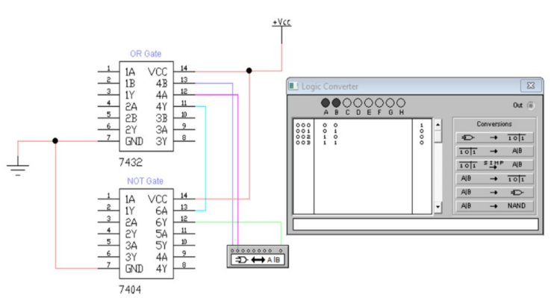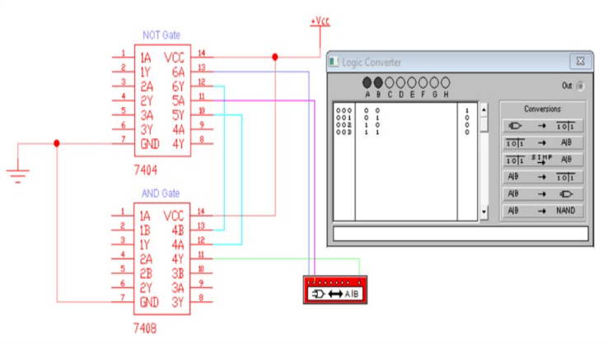**🔌 Circuit 2: DeMorgan’s Second Theorem**(A+B)’=A’⋅B’

➡️ Compare both outputs using **two LEDs**

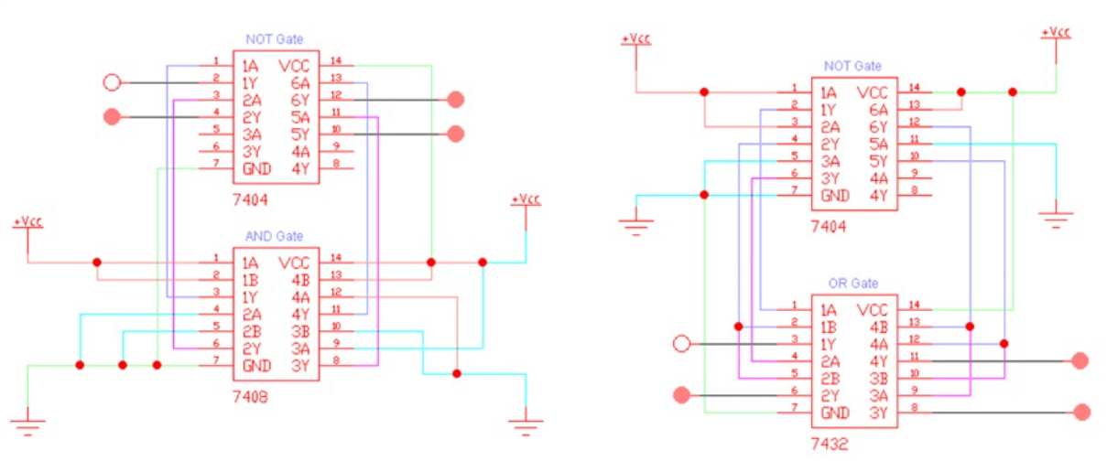

**Truth Table - Second Theorem**

|  |  |  |  |  |  |  |  |
| --- | --- | --- | --- | --- | --- | --- | --- |
| A | B | A+B | ¬(A+B) | ¬A | ¬B | ¬A·¬B | LED Status (ON = 1, OFF = 0) |
| 0 | 0 | 0 | 1 | 1 | 1 | 1 | ON |
| 0 | 1 | 1 | 0 | 1 | 0 | 0 | OFF |
| 1 | 0 | 1 | 0 | 0 | 1 | 0 | OFF |
| 1 | 1 | 1 | 0 | 0 | 0 | 0 | OFF |

✅ **Observation:** Both outputs (¬(A+B) and ¬A·¬B) are **equal in all cases**.

**Conclusion:**

From the simulation and truth tables:

* The **LEDs on both sides** of the circuit glow (ON) or turn off (OFF) identically for each combination of inputs.
* This confirms that the **left-hand side and right-hand side** of each DeMorgan’s Theorem are logically equivalent.
* Hence, **DeMorgan's Theorems are successfully verified using logic gates** in the simulated environment.

